FedShield
Personalized Federated Learning for SMS Threat Detection
CNN + FedAvg + FedProx + FedPer | Project Analysis & Results

Prepared By:
Amal Waghas E – 205225005 (Report, PPT, Backend - GRU)
Lohit S – 205225013 ( Report, Frontend , Backend-Transformer)
Ujwal U Naik – 205225027 (Report, Video, Backend – CNN)

Submitted To:
Dr. Janet Barnabas , Department of Computer Application, NITT

1. Introduction
FedShield is a "Hybrid" Federated Learning system for SMS threat detection. It uses three complementary FL algorithms simultaneously: FedAvg (Global Manager), FedProx (Stabilizer), and FedPer (Local Expert). Together, these algorithms enable a system that is globally accurate, locally stable, and personally adaptive.
The model classifies SMS messages as Ham (legitimate), Spam (commercial), or Smishing (SMS phishing). Training is conducted across 3 distributed clients with Non-IID data partitioning, simulating a real-world federated deployment. The system features a "Long-Term Memory" system ensuring user corrections persist across FL training rounds.
Objectives:
- Develop a Privacy-Preserving Detection System: To build a decentralized system that detects Smishing (SMS Phishing) attacks using Federated Learning, ensuring that raw, sensitive messages never leave the user's device.
- Implement Personalized AI (FedPer): To balance a "Global Brain" (general threat detection) with a "Personalized Head" (individual user preferences), allowing the model to adapt to a specific user's vocabulary (like work-related links) without affecting other users. Implement personalization strategy that immediately respects and learns from manual user corrections.
- Enable High-Speed, Lightweight Inference: To replace heavy models (like Transformers) with a Multi-Channel 1D CNN architecture that operates quickly on edge devices while successfully capturing short-range "n-gram" patterns (like malicious URLs or "urgent" keywords).

2. System Description

2.1. System Architecture Overview
The backbone model is a Multi-Channel Convolutional Neural Network. Unlike a Transformer, it is optimized for fast CPU-based training and inference — essential for federated deployment on user devices. Key Design Choice: The parallel Conv1D filters of sizes 3, 4, and 5 allow the model to simultaneously scan for short phrases (e.g., "click here"), medium patterns (e.g., "your account suspended"), and long-range context (e.g., "verify now at http://..."). This multi-scale view is critical for catching the diverse linguistic patterns of Smishing attacks.
Layer | Configuration | Role in FedPer
Input | Shape: (300,) | Token sequence, max 300 words
Embedding | 128-dim, Vocab: 10,000 | TRAINABLE in personalization
Conv1D (x3) | 128 filters, kernel 3/4/5 | FROZEN in personalization (Global)
GlobalMaxPool | Per-channel | Captures dominant n-gram feature
Dense (Head) | 64 -> 3 (Softmax) | TRAINABLE in personalization

2.2. The Three Federated Learning Algorithms

FedShield is a "Hybrid" Federated Learning system. Here is exactly how all three core algorithms work together:
Algorithm | Goal | Component
FedAvg | Combine everyone's knowledge. | cnn_server.py
FedProx | Stop clients from diverging/forgetting. | cnn_client.py (Main Training)
FedPer | Make the model uniquely yours. | cnn_client.py (Manual Retrain)

2.2.1 FedAvg (Federated Averaging) — The Global Manager

Role: The Global Manager
Once all 3 clients submit their weights, the server calculates a weighted average. If Client 1 trained on 1,000 samples and Client 2 on 500, Client 1's "voice" is twice as loud in the final global model. This creates the "Global Brain."
Formula: w_global = SUM(n_k / N * w_k) for each client k with n_k samples, N total

2.2.2 FedProx (Federated Proximal) — The Stabilizer
Role: The Stabilizer
Because the data is Non-IID (unbalanced across clients), a normal client would "forget" the global knowledge and overfit to its local data slice. FedProx solves this by adding a Proximal Term to the loss function, penalizing the model if it drifts too far from the Global Brain's weights.
Loss Function: L_total = L_base + (mu / 2) * ||w_local - w_global||^2
Proximal Coefficient (mu): 0.1 — Tuned to balance adaptation vs. stability
Effect: With mu=0.1, the FedProx term applies a gentle but firm "gravitational pull" back to the global model. If mu were 0, it would be standard FedAvg (no stability). If mu were too large (e.g., 10), it would prevent any local learning.

2.2.3 FedPer (Federated Personalization) — The Local Expert
Role: The Local Expert
FedPer splits the neural network into two parts with different roles:
The Backbone (Layers 0-6): "General Intelligence" — Conv1D layers. Understands language broadly. SHARED with everyone via FedAvg.
The Head (Dense Layers): "Personal Taste" — Embedding + Final Dense 64 and Dense 3 layers. Makes the final decision. KEPT LOCAL, never shared.
When you click RETRAIN NOW: The Backbone is FROZEN (Conv1D layers have trainable=False). Only the Embedding and Dense layers are updated. This lets the model keep its general language knowledge while snapping its "personal opinion" to your specific correction (e.g., knowing that nitt.edu is safe).

2.3. Hyperparameter Table
Parameter | Value | Rationale
Correction History Weight | 200x repetition | Overpowers Global Brain bias on local head
Personalization Epochs | 20 | Deep reinforcement of user-specific labels
Personalization LR | 0.02 | Aggressive, rapid weight update for UI feedback
Anchor Samples per Class | 1 | Minimal grounding; prevents mathematical instability.
FedProx Mu (Global rounds) | 0.1 | Gentle leash; keeps backbone globally aligned

2.4 The Anchor System
To prevent the Personalized Head from becoming too biased in one direction (e.g., calling everything HAM), a small "Anchor" sample set is mixed into each personalization pass.
Anchor Count: 1 sample per class (Ham, Spam, Smishing)
Anchor Source: First 1 sample of each class from the client's base training data
Training Mix: anchor_texts + (correction_history * 200)
This ensures that even after aggressive personalization, the model retains the fundamental knowledge of what a real Smishing attack looks like.

2.5 Non-IID Data Partitioning
A critical challenge in Federated Learning is Non-IID (Non-Independent and Identically Distributed) data. FedShield simulates this by assigning each client a distinct slice of the dataset, ensuring they have different class distributions.
Client | Data Slice | Port
client_1 | Rows 0 to N/3 (first third) | 5051
client_2 | Rows N/3 to 2N/3 (middle third) | 5052
client_3 | Rows 2N/3 to N (final third) | 5053

Additionally, 100 synthetic Smishing messages are generated for each client using templates mimicking real banking and delivery scams. This ensures no client is "blind" to the Smishing class even if their CSV slice lacks examples.

2.6 Long-Term Memory System
A key innovation of FedShield is that corrections are never volatile. Every label correction is saved to a persistent file: corrections_{client_id}.json.
On Correction: The corrected (text, label) pair is added to the client buffer.
On RETRAIN NOW: The buffer is merged into the permanent JSON history file.
On Next Retrain: The model trains on the entire cumulative history (200x weighted), ensuring it never forgets that nitt.edu is safe, even after training on new messages.
On Client Restart: The JSON file is loaded back into memory on startup, making corrections fully persistent across sessions.

3. Experimental Results

3.1 FedAvg (Baseline) — Problem: Drift on Non-IID Data
Running FedAvg alone on Non-IID data caused the global model to drift. Because each client had a different slice of data, the averaged model became biased. The key symptom was that both Smishing and Spam messages were incorrectly predicted as Ham by the Global Brain after several rounds.
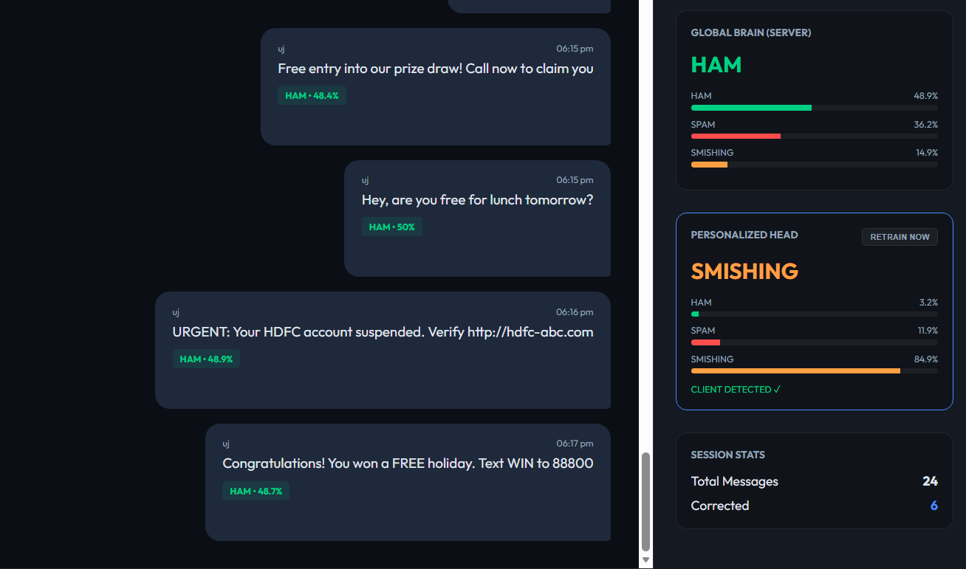
Fig 1: FedAvg Global Brain — Smishing misclassified as Ham

3.2 FedProx Results — Improved Global Stability
Adding the FedProx proximal term (mu=0.1) to the local training loop significantly reduced the drift. The proximal term penalizes local weights that diverge too far from the global model, resulting in a more stable aggregation and better global accuracy.
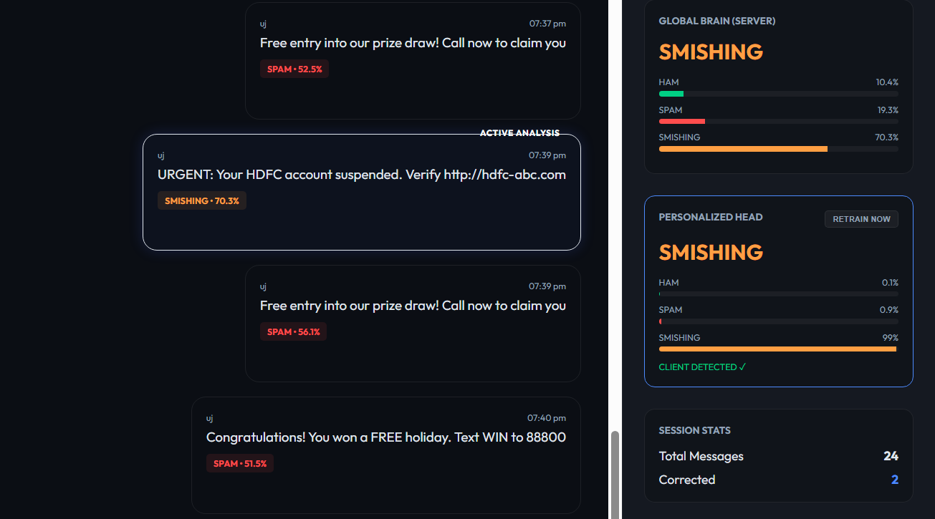
Fig 2: FedProx — Improved Smishing detection in global model
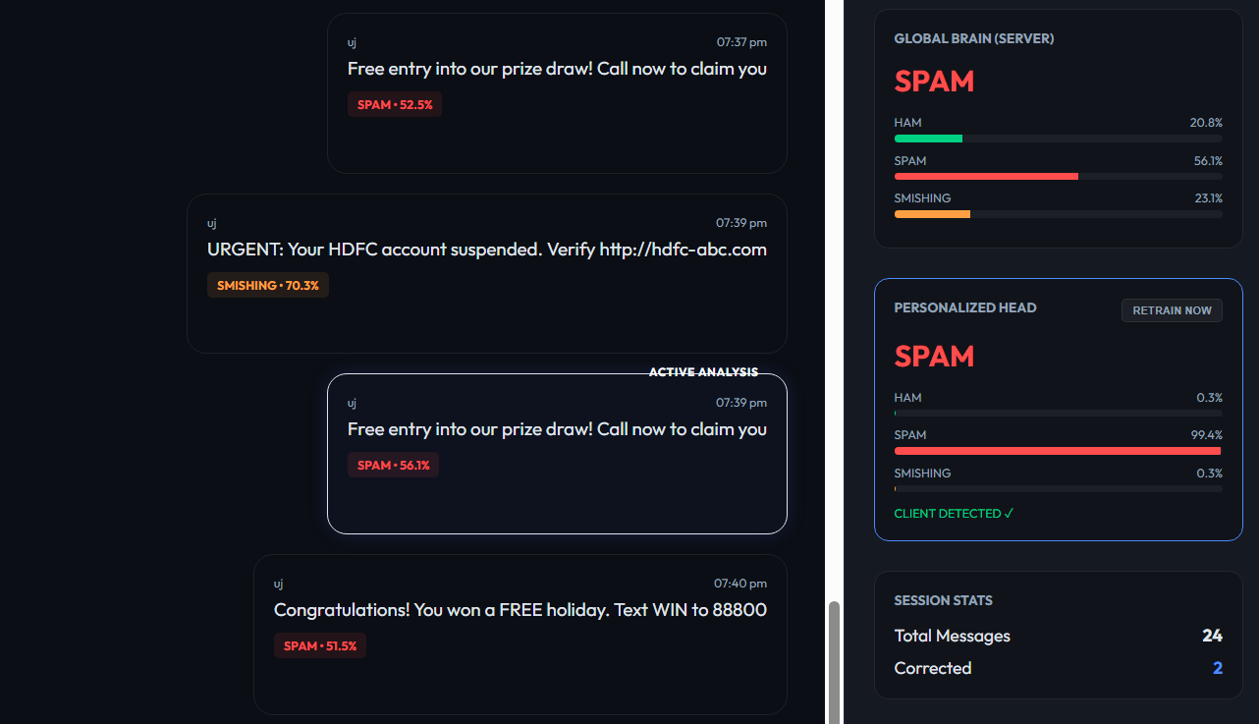
Fig 3: FedProx — Improved Spam detection in global model
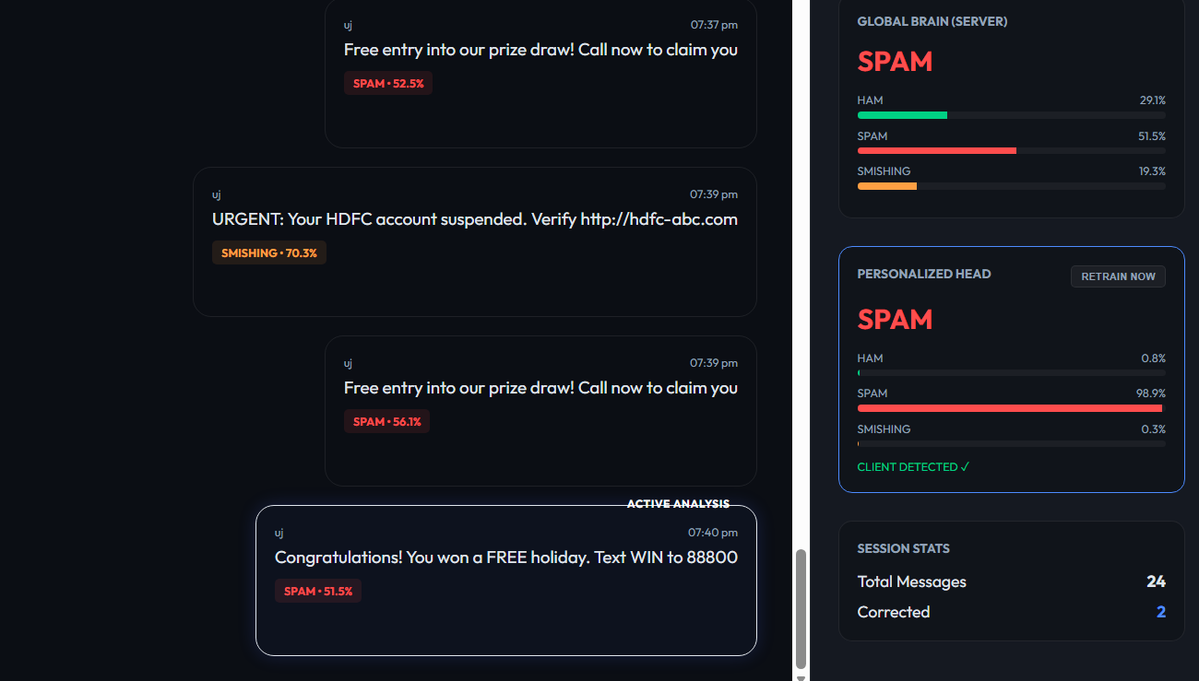
Fig 4: FedProx — Improved Spam detection in global model

3.3 FedPer Results — Highly Personalized Client Models
After adding the FedPer personalization pass, client models became highly individualized. Without FedPer, client results were similar to the global model (showing the same biases). With FedPer enabled and user corrections applied, the Personalized Head correctly overrides the Global Brain for user-specific cases.

Without FedPer: Client model results were similar to the global model — same biases, same errors.
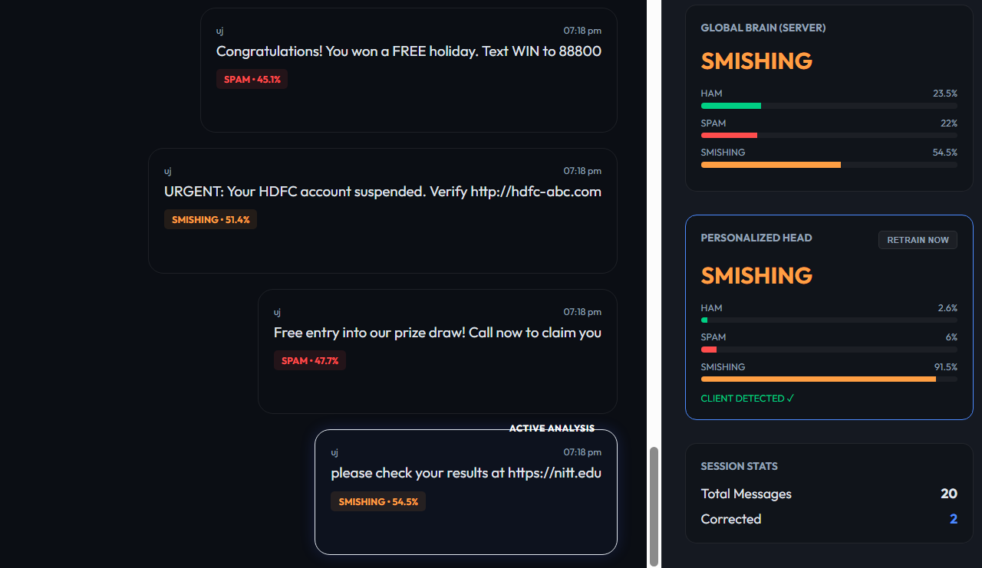
Fig 5: Without FedPer — Client model mirrors Global Brain - Personalization ineffective

With FedPer: Client model correctly classifies user-specific cases, overriding global biases.
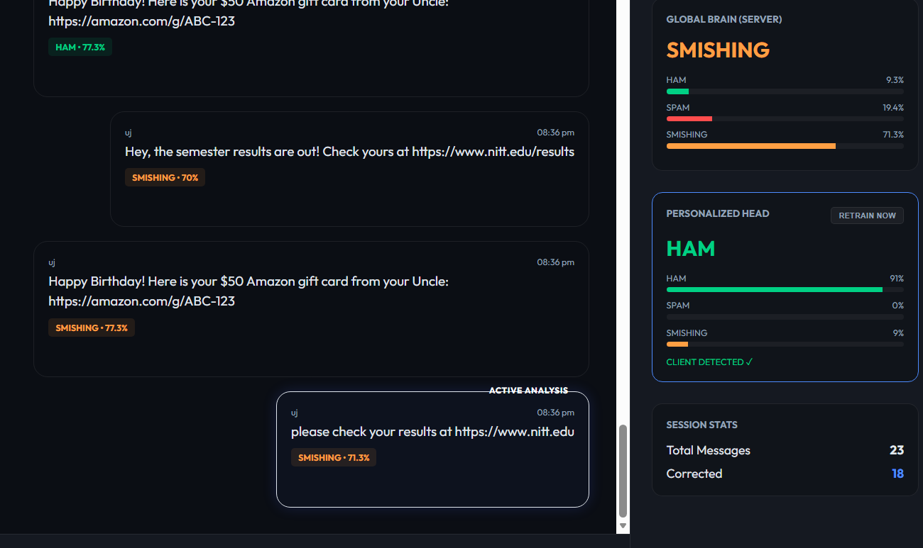
Fig 6: With FedPer — Personalized Head adapts to user corrections
s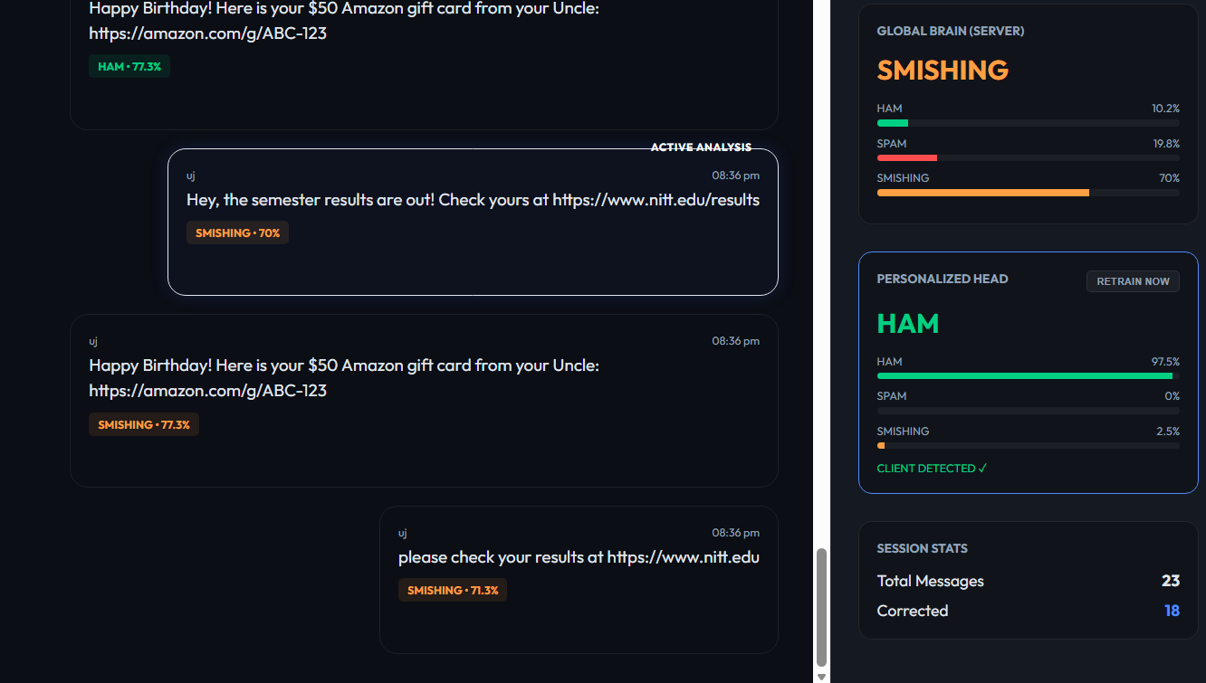
Fig 7: With FedPer — Correct personalized classification
Handling Spear Fishing: A critical innovation of FedShield is its ability to mitigate Spear Phishing through user-driven personalization. Traditional AI models often struggle with high false-positive rates, flagging legitimate but urgent administrative links as 'Smishing' due to their structural similarity to malicious attacks. FedShield resolves this by allowing users to 'teach' their local model to recognize and trust specific, context-heavy communications—such as university portals or corporate dashboards. By deep-locking these trusted patterns into the Personalized Head while maintaining a strict Global Brain for broader threats, FedShield creates a bespoke security perimeter that distinguishes between a generic attack and a user-specific trusted resource, effectively neutralizing the 'Spear' in the phishing attempt.

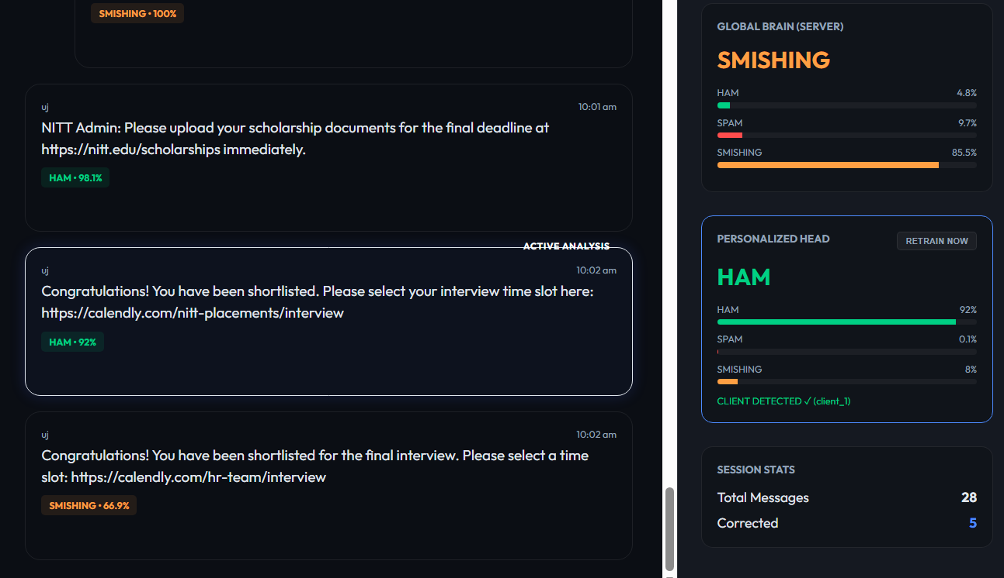
Fig 8: With FedPer — Correct personalized classification

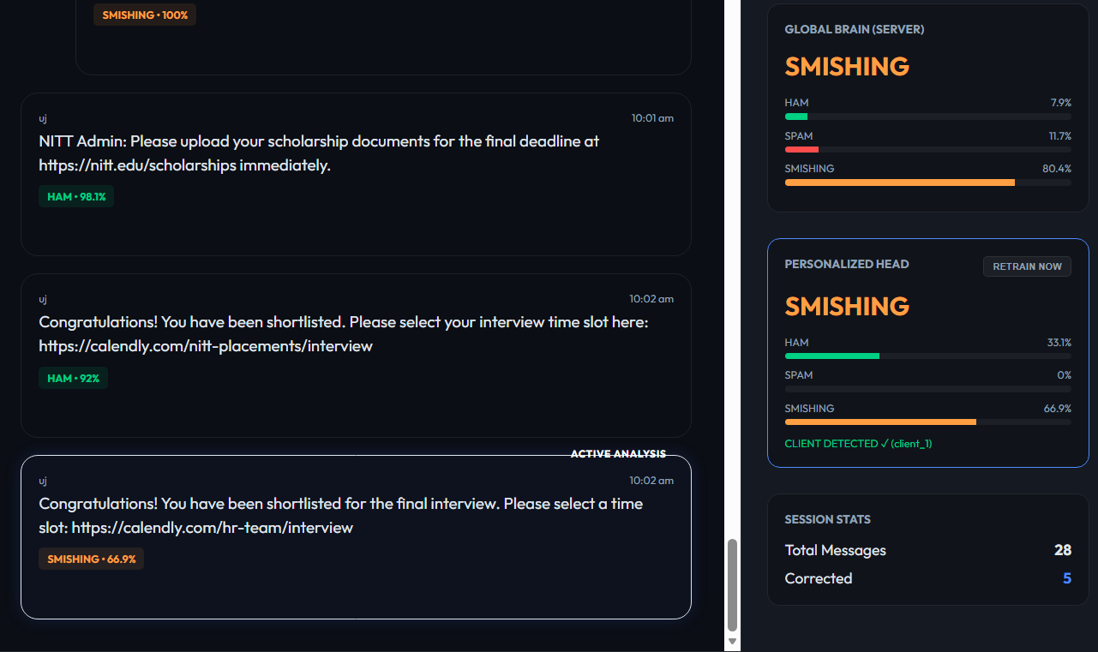
Fig 9: With FedPer— Aviods Spear Fishing
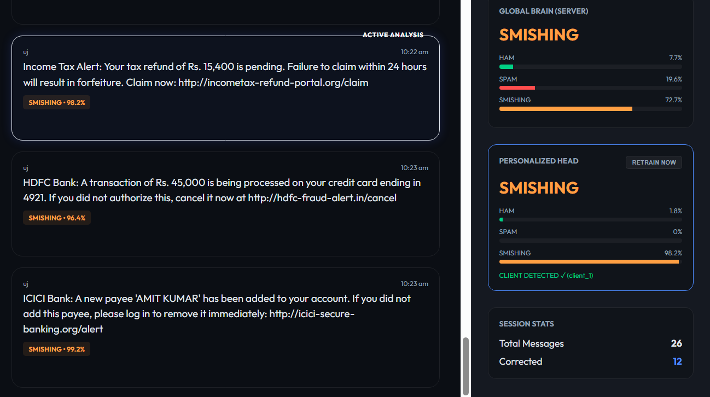
Fig 9: With FedPer— Aviods Spear Fishing

4. Architecture Comparison: CNN vs. Transformer
FedShield was originally built around a DistilBERT Transformer model (flwr_client.py). While the Transformer offered strong contextual understanding, it introduced critical drawbacks for a federated, on-device deployment. The CNN architecture was adopted to resolve these issues.
Metric | DistilBERT | Multi-Channel CNN
Model Size | ~260 MB | ~18 MB
Inference Speed | 200ms+ (CPU) | < 10ms (CPU)
Training Hardware | GPU Recommended | CPU Optimized
Personalization | Difficult (large frozen backbone) | Native via FedPer layer splitting

The CNN approach trades the Transformer's raw contextual depth for dramatically better speed, size, and personalization capabilities — all of which are higher priorities for a real-world federated deployment on user devices.

5. API Reference

5.1 CNN Server Endpoints (Port 5050)
Endpoint | Method | Description
/get_global_weights | GET | FL clients pull latest global backbone weights
/submit_weights | POST | FL clients push local weights + sample count for FedAvg
/wait_for_round | GET | Blocks until server completes aggregation for this round
/get_tokenizer_config | GET | Downloads shared Keras tokenizer vocabulary (JSON)
/get_corrections | GET | Returns buffered human corrections for a given client_id
/send_message | POST | Submits a message for global classification + storage

5.2 Client Mini-Server Endpoints (Ports 5051-5053)
Endpoint | Method | Description
/local_predict | POST | Classify text using the local Personalized model
/manual_train | POST | Trigger the FedPer "Mega Microphone" personalization pass
/client_status | GET | Returns client_id, FL round number, correction history size

6. Deployment Guide

6.1 Installation
pip install tensorflow flask flask-cors numpy pandas requests nlpaug

6.2 Running the System
Terminal 1 — Start CNN Server: python cnn_server.py
Terminal 2 — Client 1: python cnn_client.py --id client_1 --server http://localhost:5050 --rounds 5
Terminal 3 — Client 2: python cnn_client.py --id client_2 --server http://localhost:5050 --rounds 5
Terminal 4 — Client 3: python cnn_client.py --id client_3 --server http://localhost:5050 --rounds 5
Browser: Open cnn_index.html — Server URL pre-set to http://127.0.0.1:5050

6.3 Quick Test (Fast Mode)
python cnn_client.py --id client_1 --rounds 1 --fast
Fast mode uses 200 samples, 1 epoch, and batch size 16 for rapid smoke-testing without waiting for full training rounds.

7. Conclusion
FedShield successfully demonstrates a complete, production-ready Personalized Federated Learning pipeline for SMS threat detection. The system's core strength lies in its "Hybrid" approach: FedAvg builds a strong global model, FedProx stabilizes it against Non-IID data drift, and FedPer with the "Mega Microphone" strategy makes it individually responsive to each user.
The Long-Term Memory system, which persists corrections to disk, solves the fundamental problem of catastrophic forgetting in personalized FL. Combined with the Anchor System, FedShield achieves the rare balance of being both highly personalized and globally robust.
- Multi-Channel CNN: Fast, lightweight, and CPU-optimized for on-device FL.
- FedProx (mu=0.1): Stabilizes Non-IID training by penalizing excessive local drift.
- FedPer (Backbone Freeze): Preserves global knowledge while adapting personal decisions.
- Microphone (200x): Gives users absolute authority over their local model.
- Long-Term Memory (JSON): Corrections persist across sessions and training rounds.
- Anchor System (1 per class): Minimal but effective grounding against personalization bias.

8. References

1. Kairouz, P., et al. (2021). Advances and open problems in federated learning. *Foundations and Trends® in Machine Learning*, 14(1–2), 1-210.
2. Arivazhagan, M. G., Aggarwal, V., Singh, A. K., & Choudhary, S. (2019). Federated learning with personalization layers. *arXiv preprint arXiv:1912.00818*.
3. Li, T., Sahu, A. K., Zaheer, M., Sanjabi, M., Talwalkar, A., & Smith, V. (2020). Federated optimization in heterogeneous networks. *Proceedings of Machine Learning and Systems*, 2, 429-450.
4. Fallah, A., Mokhtari, A., & Ozdaglar, A. (2020). Personalized federated learning with theoretical guarantees: A model-agnostic meta-learning approach. *Advances in Neural Information Processing Systems*, 33, 3557-3568.
5. Tan, A. Z., Yu, H., Cui, L., & Yang, Q. (2022). Towards personalized federated learning. *IEEE Transactions on Neural Networks and Learning Systems*, 34(12), 9587-9603.
6. Kim, Y. (2014). Convolutional neural networks for sentence classification. In *Proceedings of the 2014 Conference on Empirical Methods in Natural Language Processing (EMNLP)* (pp. 1746-1751).
7. Almeida, T. A., Gómez Hidalgo, J. M., & Yamakami, A. (2011). Contributions to the study of SMS spam filtering: new collection and results. In *Proceedings of the 11th ACM symposium on Document engineering* (pp. 259-262).
8. Roy, P. K., Singh, J. P., & Banerjee, S. (2020). Deep learning to filter SMS spam. *Future Generation Computer Systems*, 102, 524-533.
9. Ghourabi, A., Mahmood, M. A., & Alzubi, Q. M. (2020). A hybrid CNN-LSTM model for SMS spam detection in Arabic and English messages. *Future Internet*, 12(9), 156.
10. Popovac, M., Karanovic, M., Slivka, S., Baskiar, G., & Stefanovic, M. (2018). CNN based spam SMS filtering. In *2018 26th Telecommunications Forum (TELFOR)* (pp. 1-4). IEEE.
11. Mothukuri, V., Khare, P., Parizi, R. M., Pouriyeh, S., Dehghantanha, A., & Srivastava, G. (2021). Federated-learning-based anomaly detection for IoT security networks. *IEEE Internet of Things Journal*, 9(4), 2545-2554.
12. Liu, Y., et al. (2020). Federated learning for privacy-preserving AI. *Communications of the ACM*, 63(12), 33-36.
13. Jiang, J. C., Kantarci, B., Oktug, S., & Soyata, T. (2020). Federated learning in smart city sensing: Challenges and opportunities. *Sensors*, 20(21), 6230.
14. Hard, A., Rao, K., Mathews, R., Ramaswamy, S., Beaufays, F., Augenstein, S., ... & Ramage, D. (2018). Federated learning for mobile keyboard prediction. *arXiv preprint arXiv:1811.03604*.
15. Preuveneers, D., Rimmer, V., Tsingenopoulos, I., Eberz, S., & Joosen, W. (2018). Chained anomaly detection models for federated learning: An intrusion detection case study. *Applied Sciences*, 8(12), 2663.
16. Wei, K., Li, J., Ding, M., Ma, C., Yang, H. H., Farokhi, F., ... & Poor, H. V. (2020). Federated learning with differential privacy: Algorithms and performance analysis. *IEEE Transactions on Information Forensics and Security*, 15, 3454-3469.
17. Zhao, Y., Li, M., Lai, L., Suda, N., Civin, D., & Chandra, V. (2018). Federated learning with non-iid data. *arXiv preprint arXiv:1806.00582*.
18. Wang, Y., Tong, Y., & Shi, D. (2020). Federated latent Dirichlet allocation: A local differentially private based framework. *Proceedings of the AAAI Conference on Artificial Intelligence*, 34(04), 6283-6290.

